Sensitivity analysis and comparison with other (possibly frequentist) methods are optional, but desirable. Any important computer code (OpenBUGS or R) that you used should be carefully documented and included as an appendix.

**Further Exploration on Frequentist Approach**

For normal Bayesian hierarchical model, we perform frequentist method on it. The maximum likelihood estimators (MLE) and confidence intervals are listed below:

μi ≈ Xi

μij ≈ Xij

σ2i ≈ S2i

σ2ij ≈ S2ij

Confidence interval of μij: (μij, μij +)

Confidence interval of σ2ij: ( S2ij , S2ij)

where z is the upper (1- α)/2 = 1.96 critical value for the standard normal distribution, α = 95%.

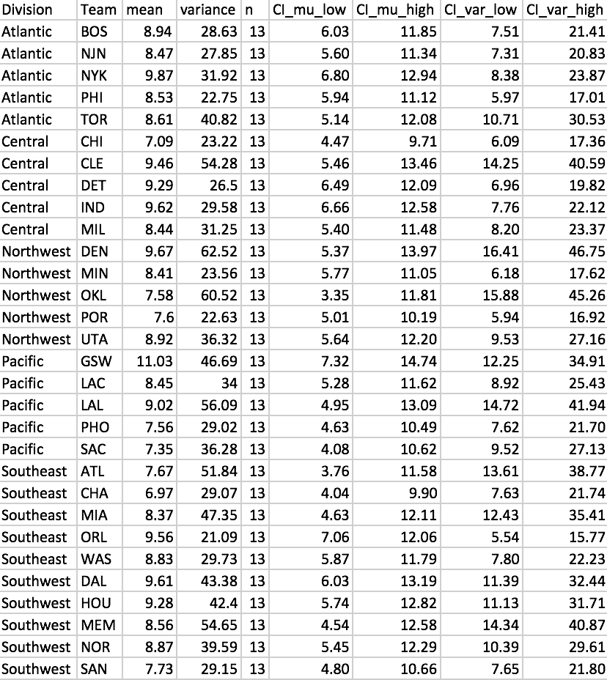

**Table 3.** Frequentist approach results of μij in each division and team

Compared with the results of normal Bayesian hierarchical model in Table 1, the differences between two μij estimators are consistently small. And all the confidence intervals of frequentist method are wider than these of normal Bayesian hierarchical model. Large variance shows that the players have different average levels in each team.

|  |  |  |  |  |  |  |
| --- | --- | --- | --- | --- | --- | --- |
| Methods | Atlantic | Central | Northwest | Pacific | Southeast | Southwest |
| Frequentist | 8.88 | 8.78 | 8.43 | 8.68 | 8.28 | 8.81 |
| Bayesian | 8.635 | 8.716 | 8.708 | 8.656 | 8.58 | 8.619 |

**Table 4.** Comparison between Frequentist and Bayesian approaches for μi

Both the frequentist and Bayesian methods results for μi are approximately 8.5 and difference between each pair is very small. That indicates that results of Bayesian model seems good and the differences of Players’ Points Per Game (PPG) between different divisions are small. Players in each division have close average levels.

|  |  |  |  |
| --- | --- | --- | --- |
| Methods | σA2(Between Division  Standard Deviation) | σB2 (Between Team Standard Deviation) | σC2(Inside Team Standard Deviation) |
| Frequentist | 0.2472 | 0.9319 | 37.09 |
| Bayesian | 0.1318 | 0.7632 | 34.7 |

**Table 5.** Comparison between Frequentist and Bayesian approaches for σ2

Based on Table 5, we can clearly see that normal Bayesian hierarchical model has slightly greater standard deviation between different divisions, between different teams and inside each team than frequentist model, but the differences are very small. That indicates that normal Bayesian hierarchical model shows representative results compared to frequentist model. Additionally, between different divisions and between teams, the results in the set are close to the mean and each other. But in each team, Players’ Points Per Game (PPG) in each set are far from the mean and each other.